|  |  |
| --- | --- |
|  | Faculty of Information Science and Technology  Universiti Kebangsaan Malaysia  43600 Bangi Selangor |
| **TTTK2103**  **Computer Network Technology** | |

**PACKET TRACER**

2.9.1 Packet Tracer - Basic Switch and End Device Configuration

2.9.2 Packet Tracer - Basic Switch and End Device Configuration - Physical Mode

|  |  |
| --- | --- |
| **Name** | **Matrix Number** |
| Mariam binti Masuan | A182976 |
| Mohamad Saiful Nizam bin Abd Aziz | A179830 |

**2.9.1 Packet Tracer - Basic Switch and End Device Configuration**

**Requirements**

* **Use a console connection to access each switch.**
* **Name ASw-1 and ASw-2 switches.**

ASw-1:

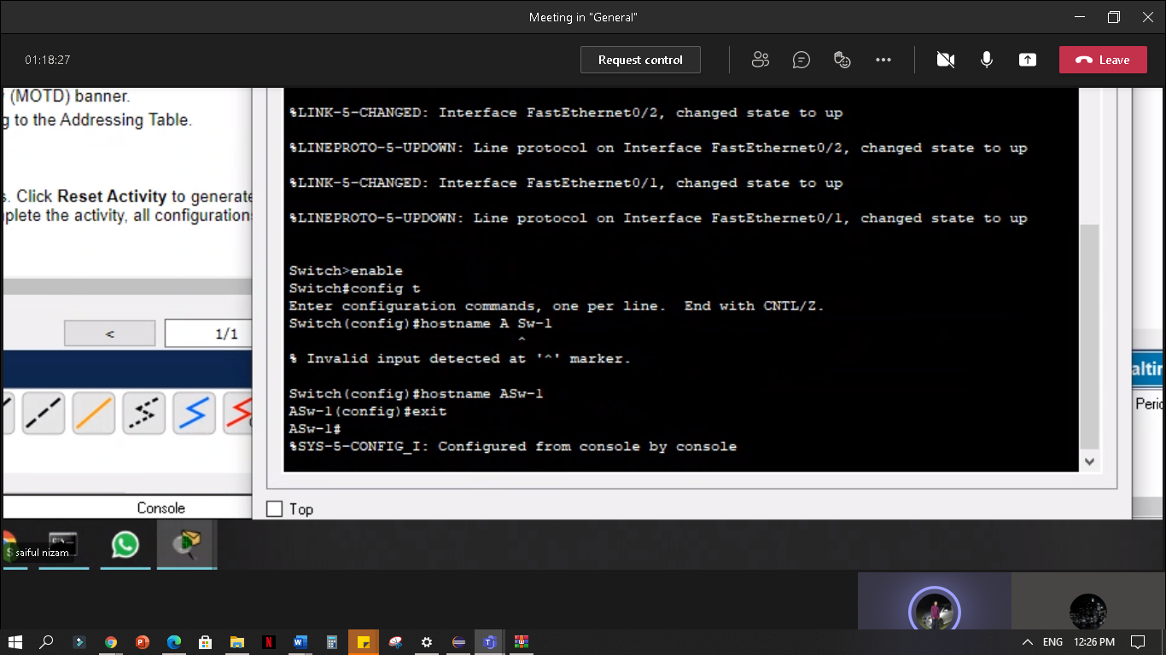

ASw-2:

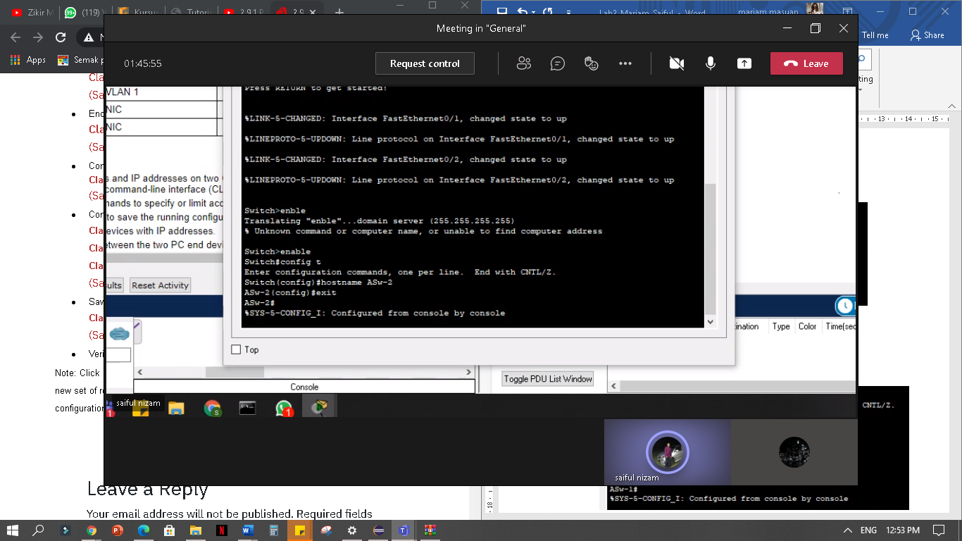

* **Use the R4Xe3 password for all lines**
* **Use the C4aJa secret password**
* **Encrypt all clear text passwords.**

ASw-1:

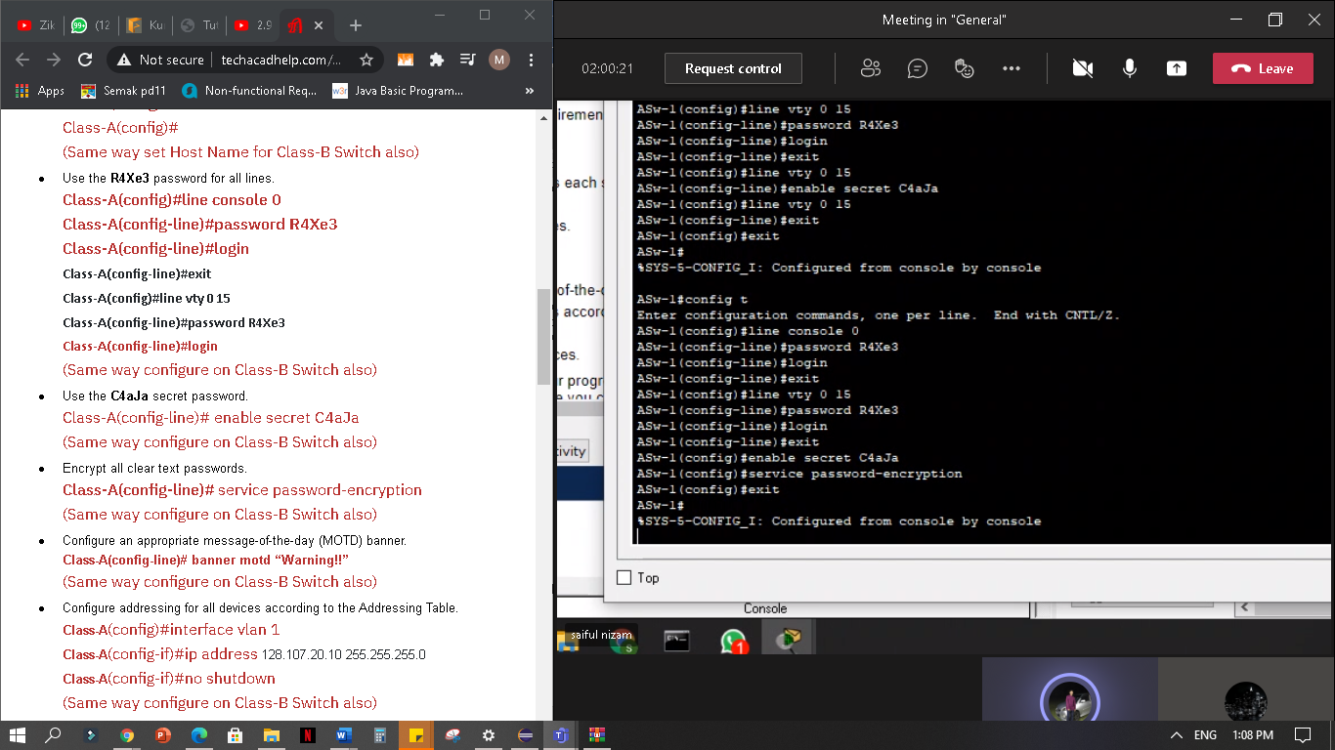

ASw-2:

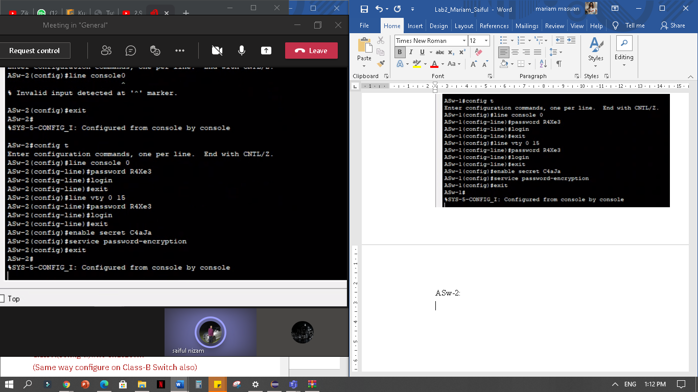

* **Configure an appropriate message-of-the-day (MOTD) banner.**

ASw-1:

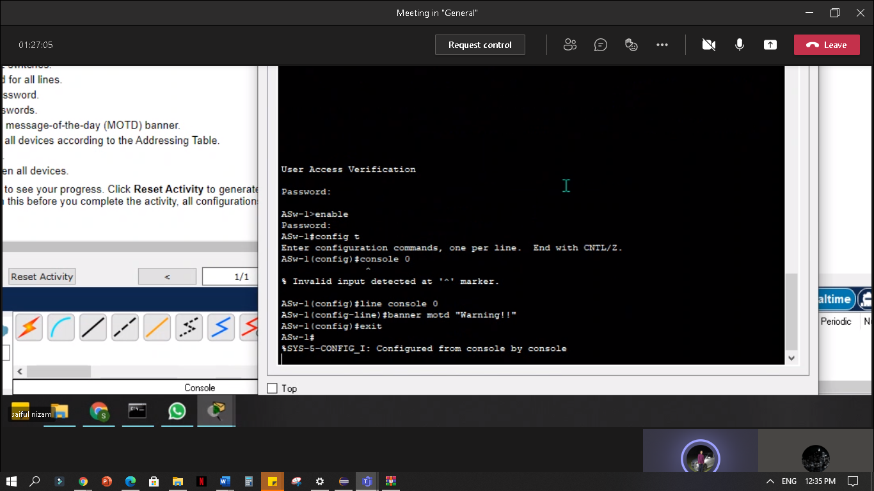

ASw-2: 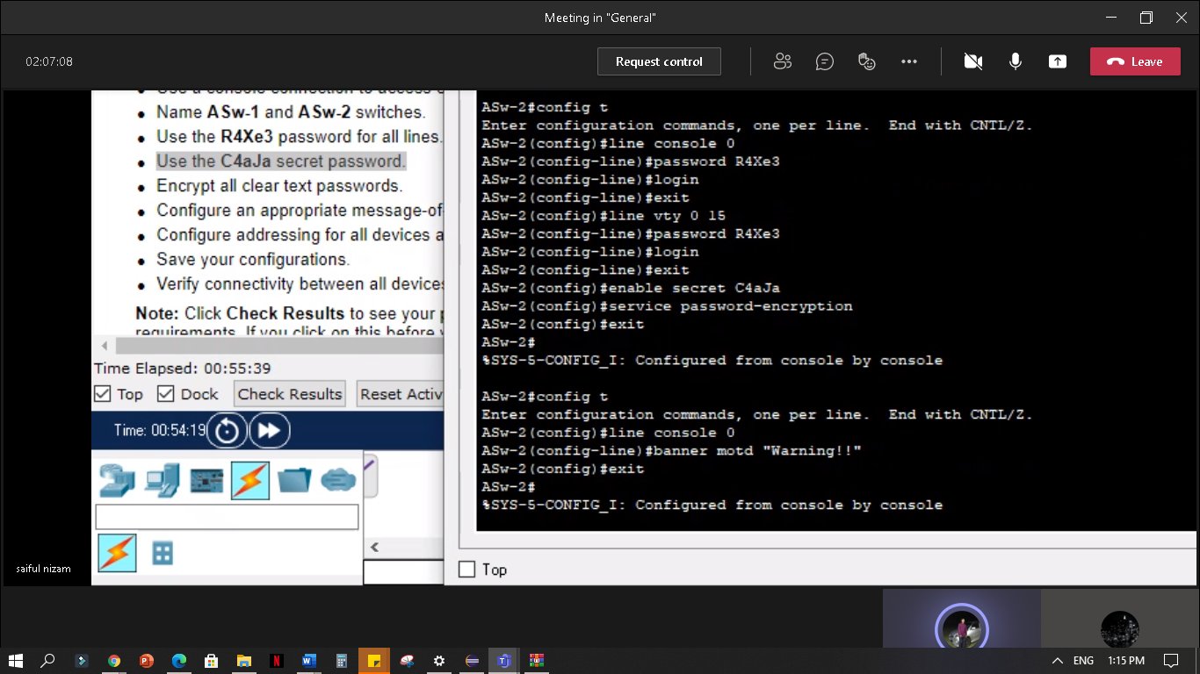

* **Configure addressing for all devices according to the Addressing Table.**

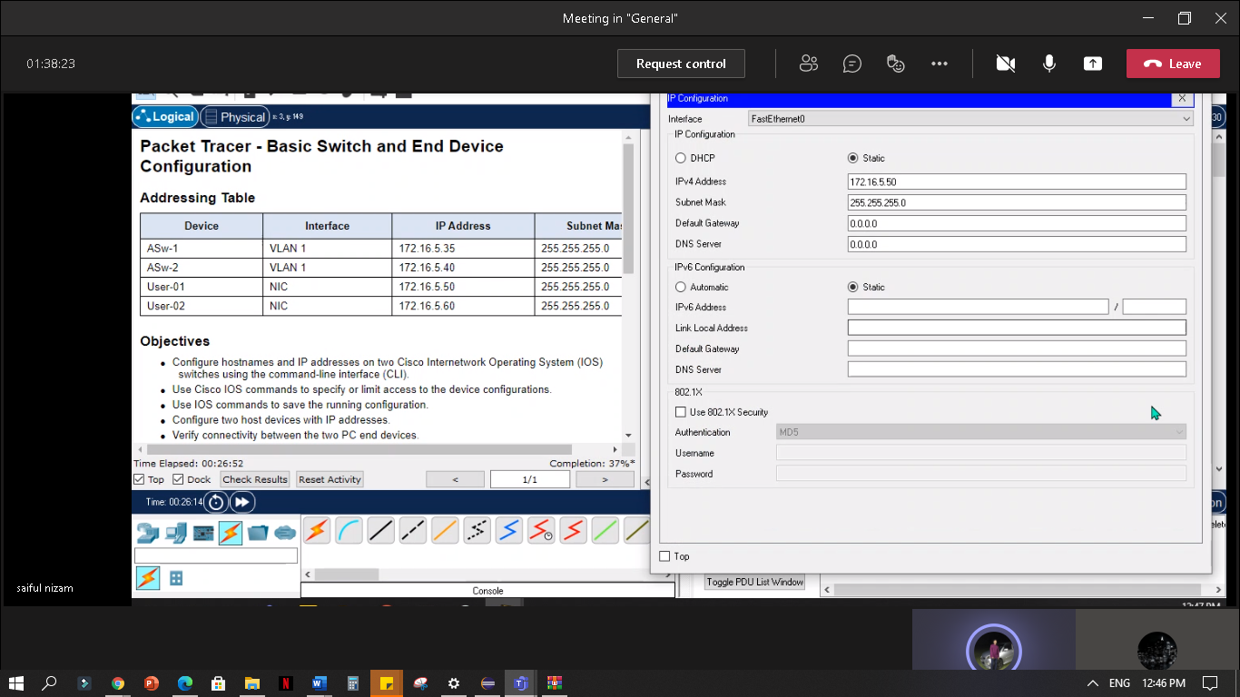User-01:

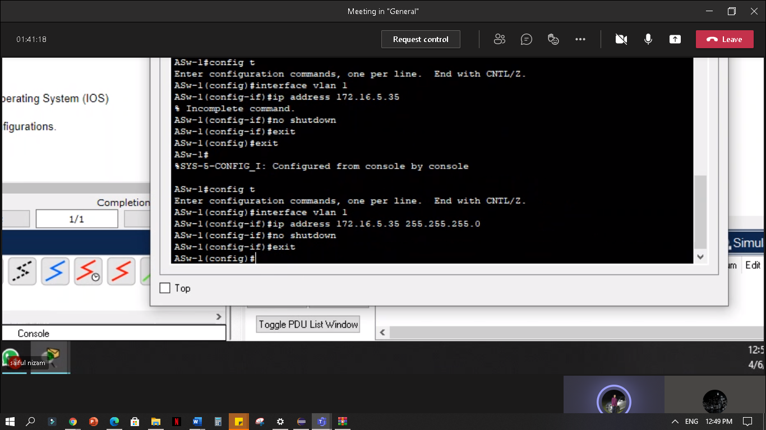ASw-1:

User-02:

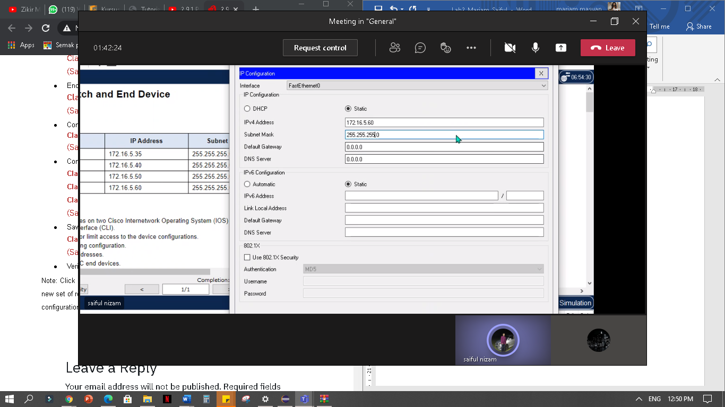

ASw-2:

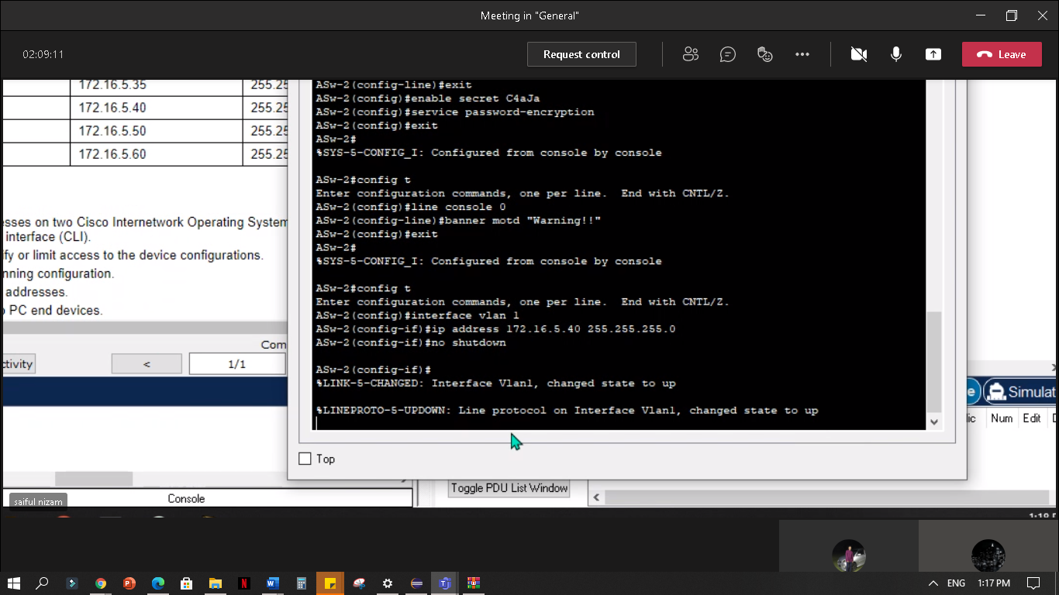

* **Save your configurations.**

User-01:

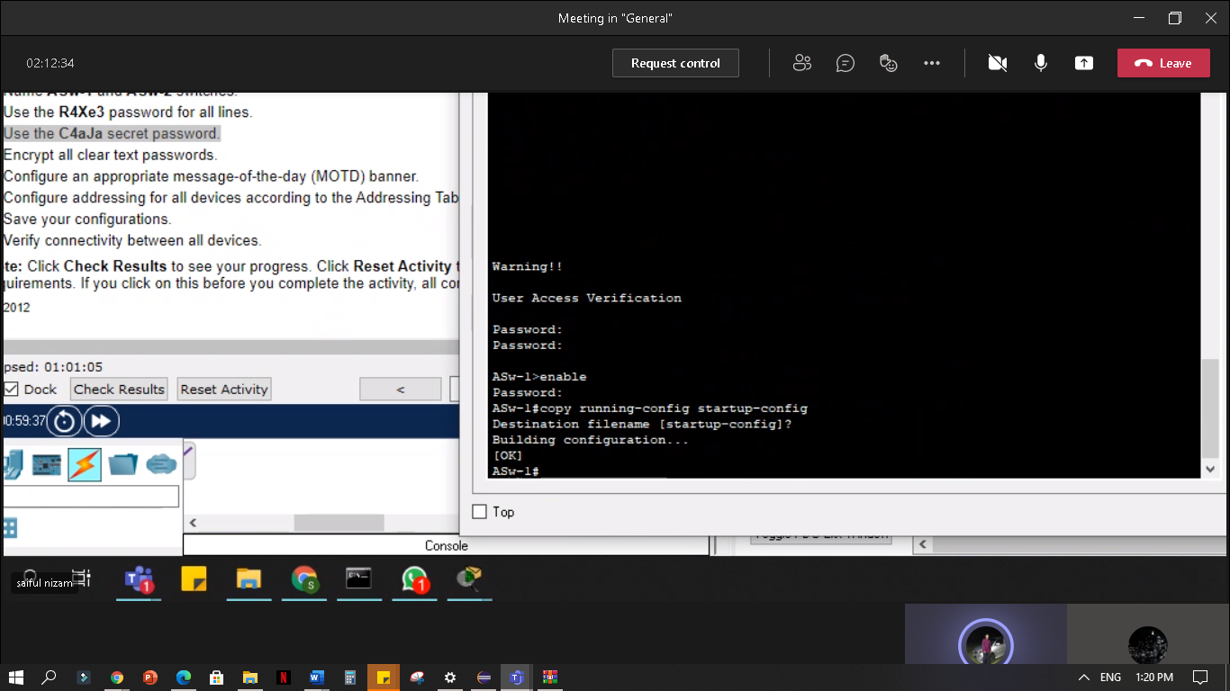

User-02:

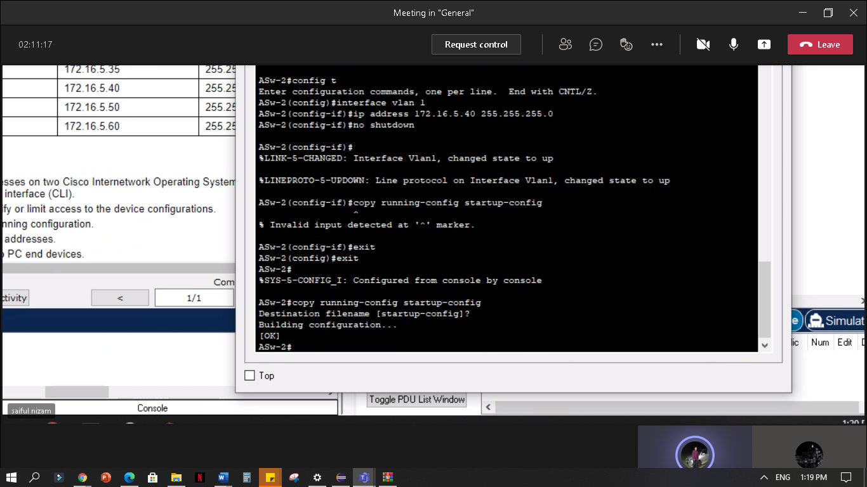

**2.9.2 Packet Tracer - Basic Switch and End Device Configuration - Physical Mode**

**Part 1: Set Up the Network Topology**

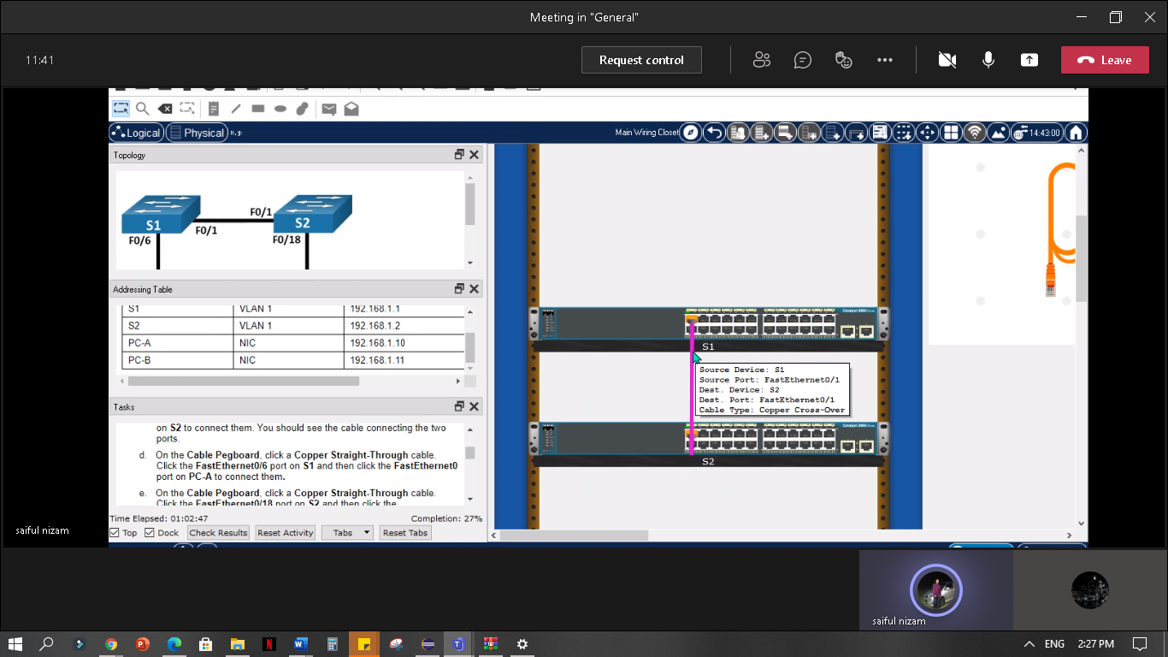

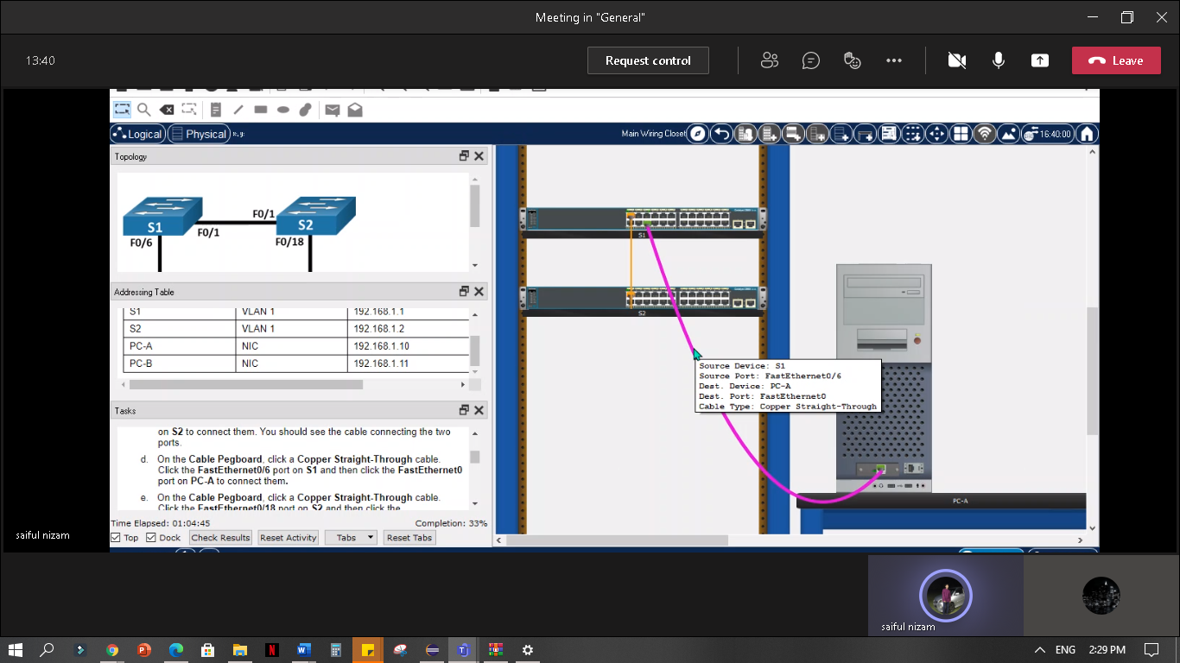

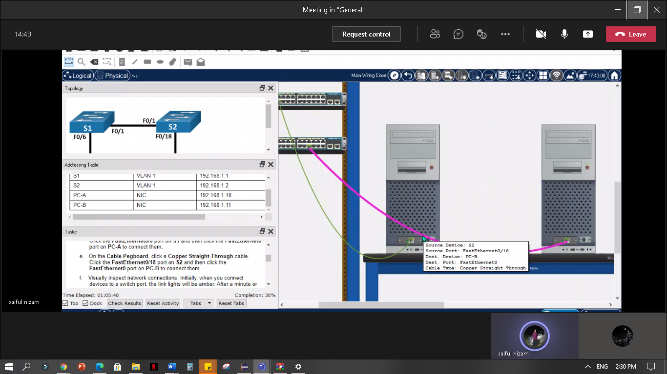

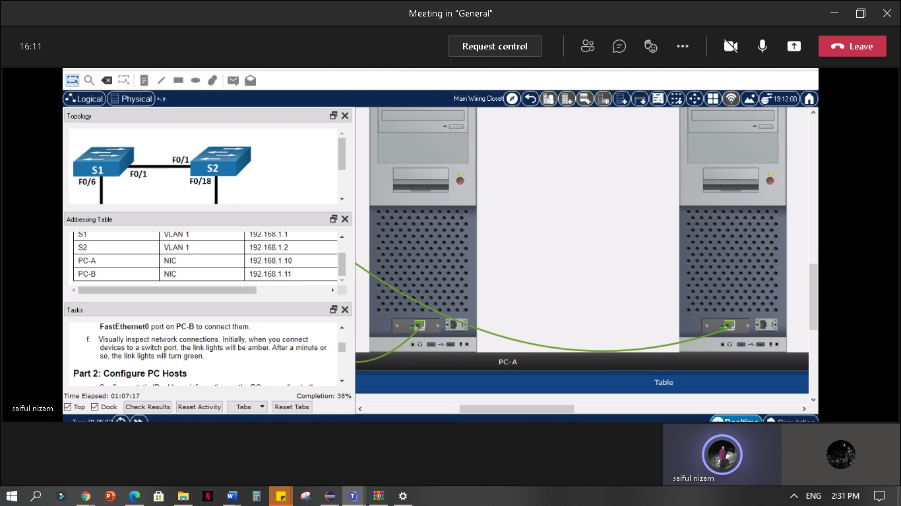

**Part 2: Configure PC Hosts**

PC-A:

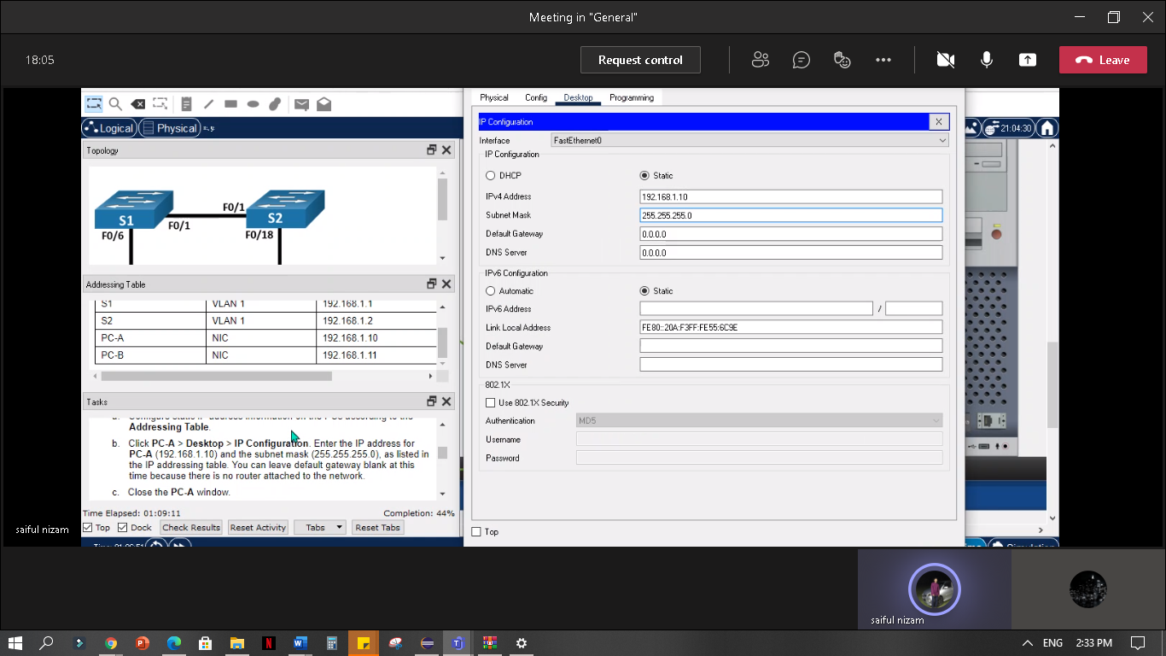

PC-B:

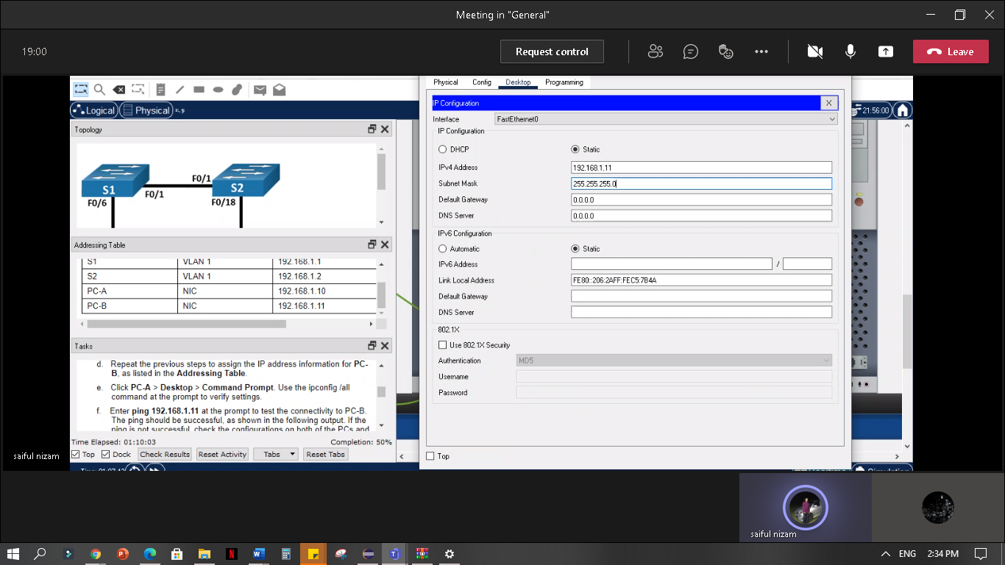PC-A:

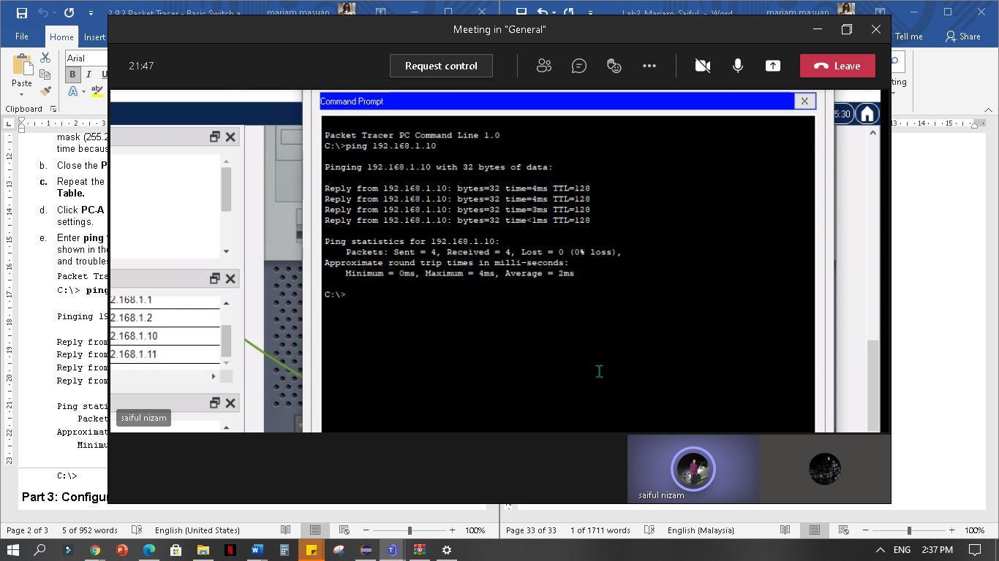

PC-B:

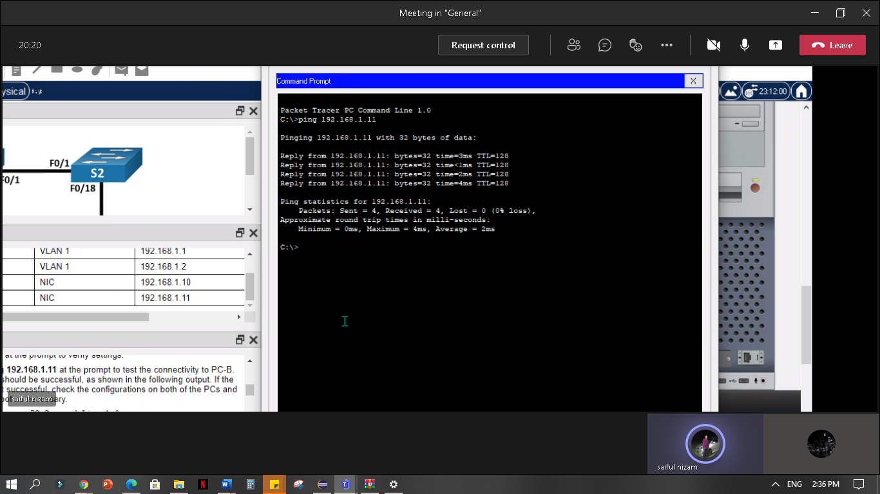

**Part 3: Configure and Verify Basic Switch Settings**

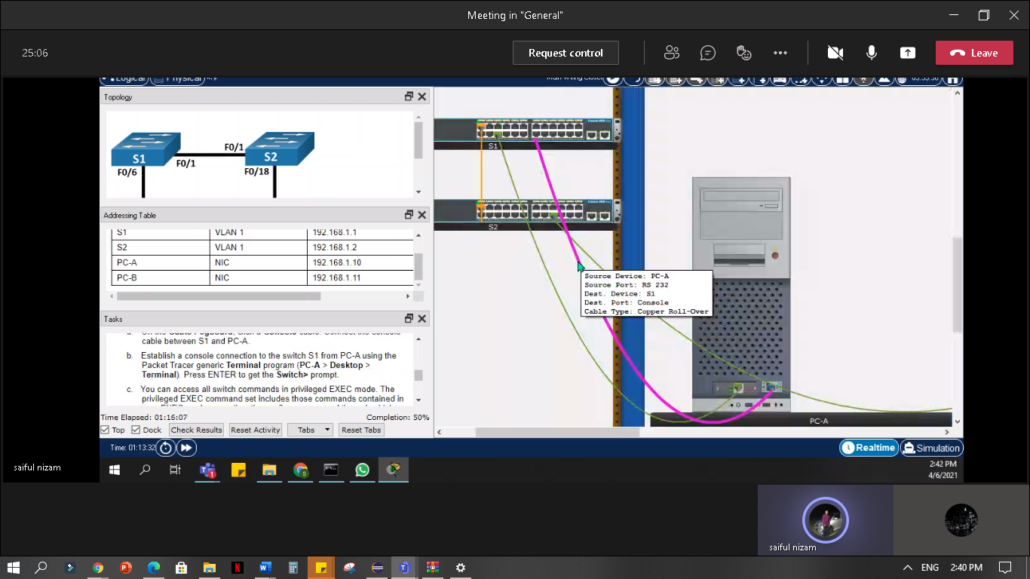**a. Connect the console cable between S1 and PC-A**

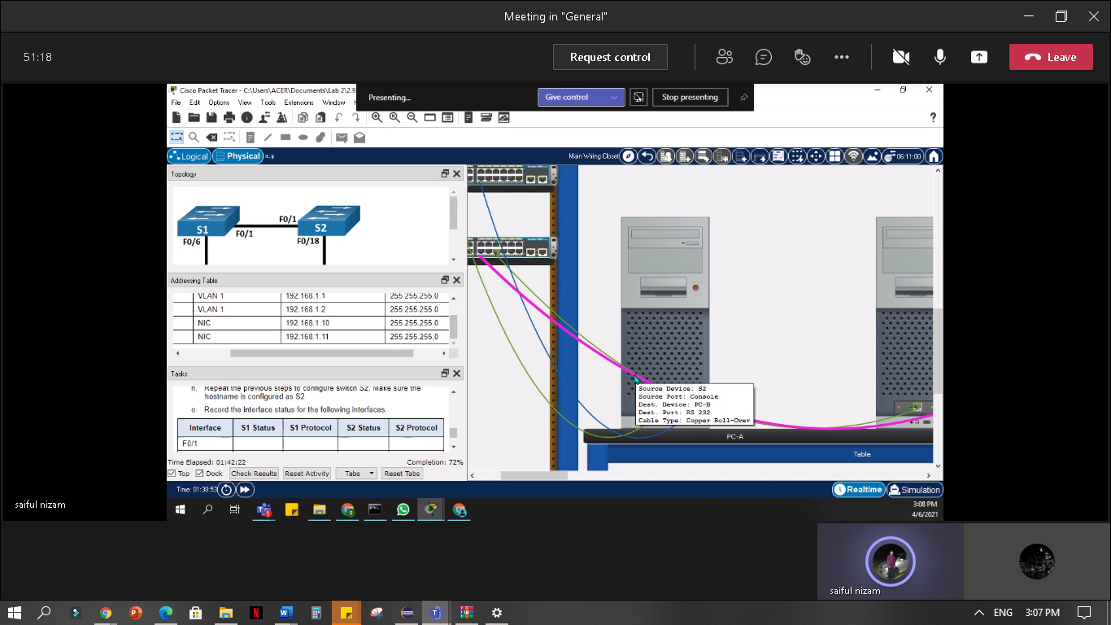

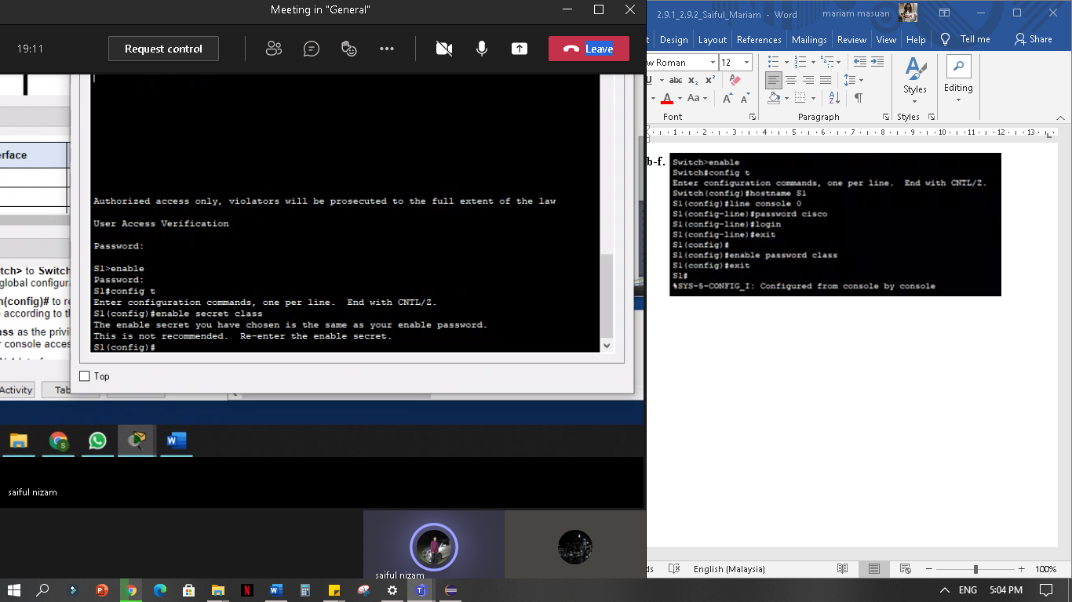**b-f.**

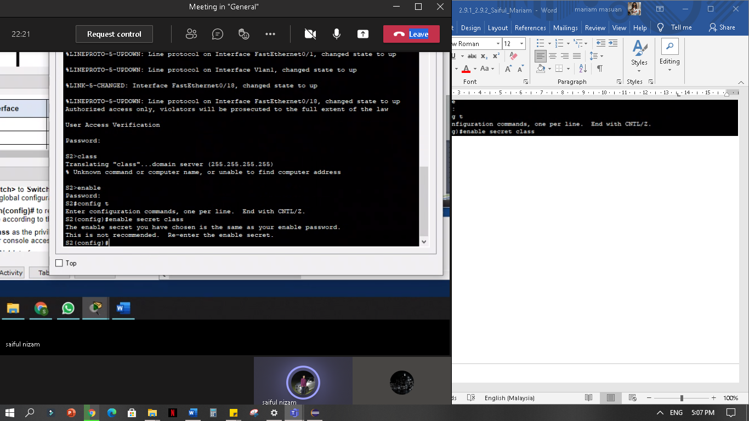

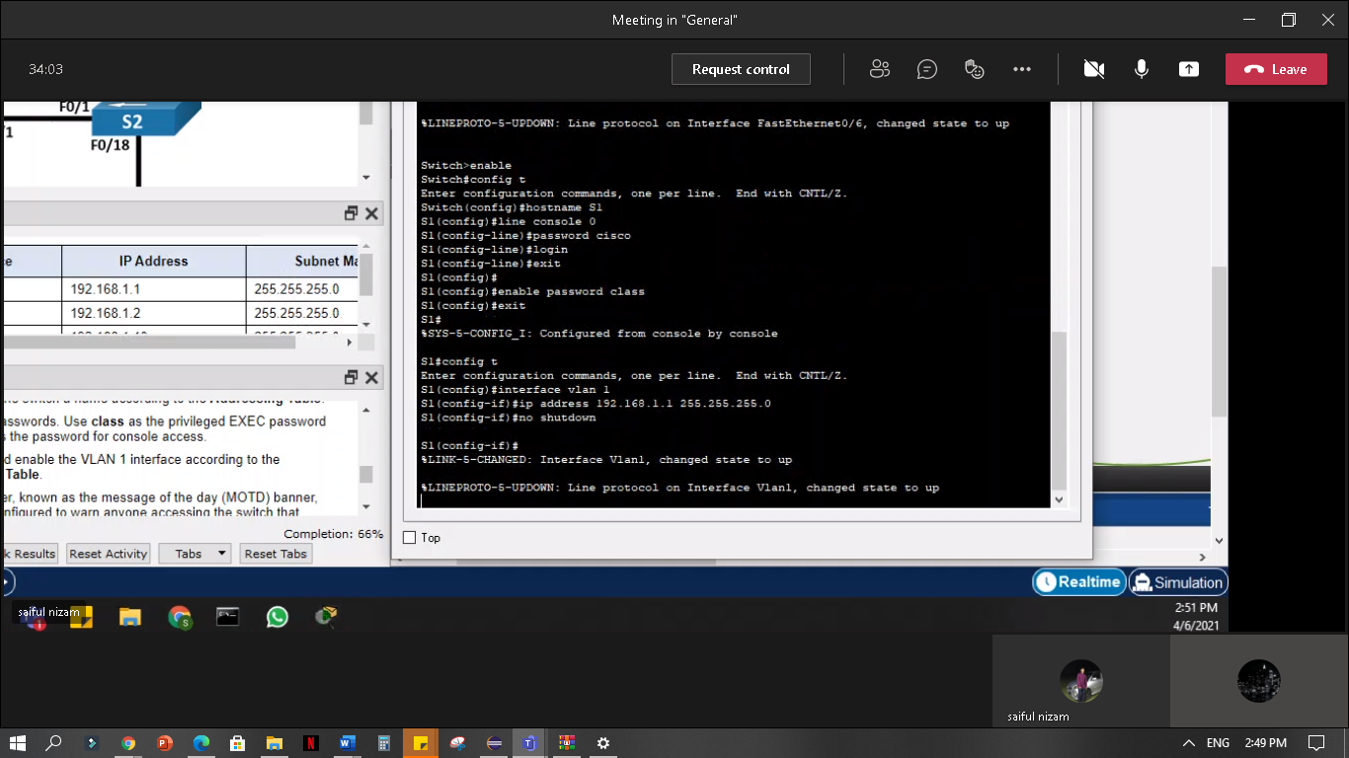**g. Configure and enable the VLAN 1 interface according to the Addressing Table.**

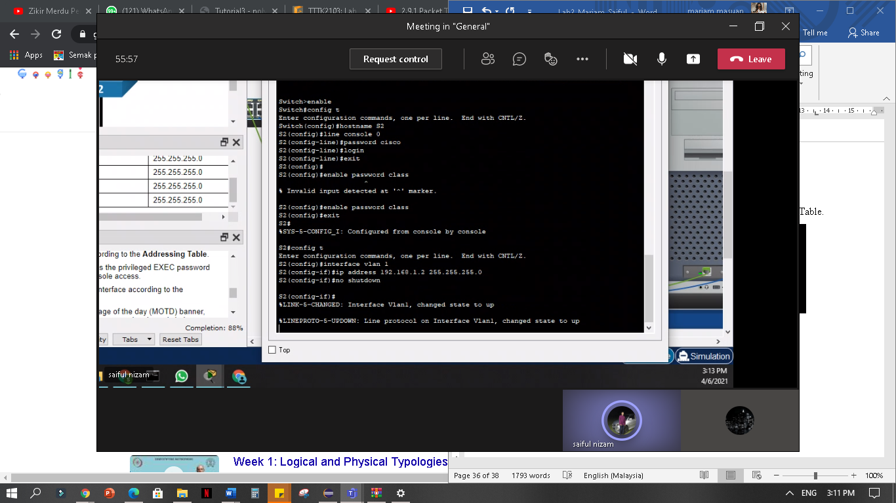

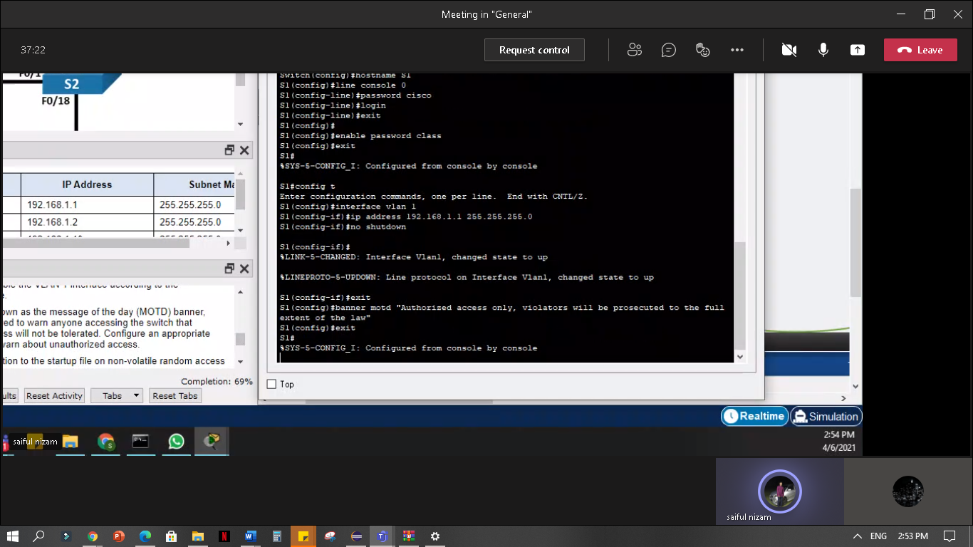**h. Configure an appropriate MOTD banner to warn about unauthorized access.**

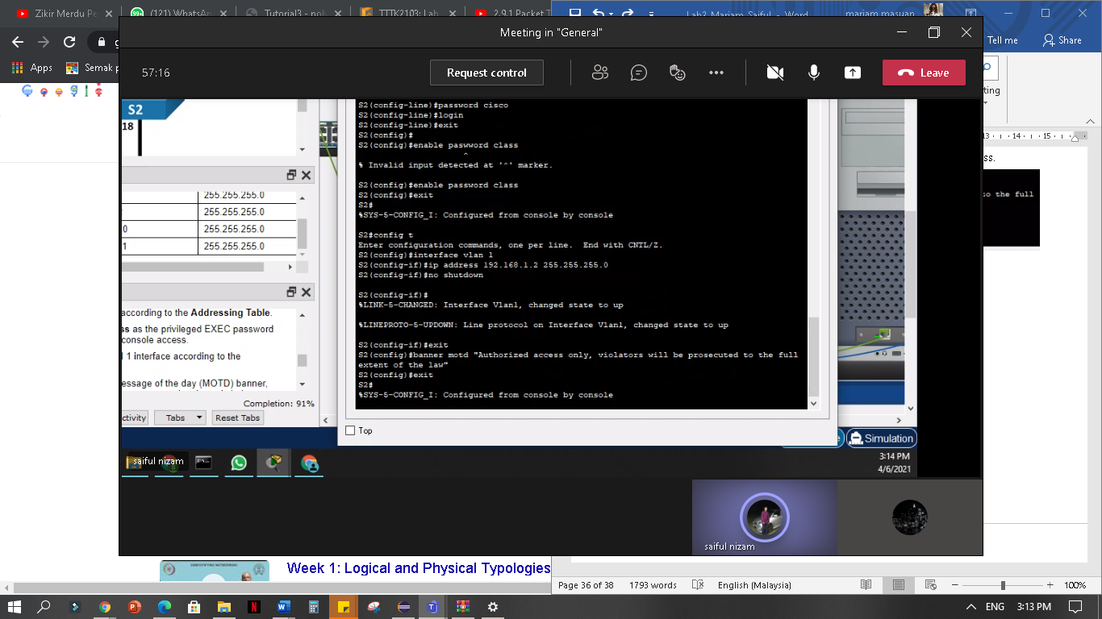

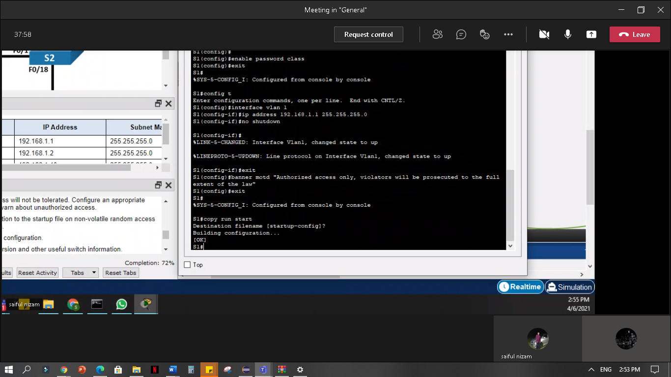**i. Save the configuration to the startup file on non-volatile random access memory (NVRAM).**

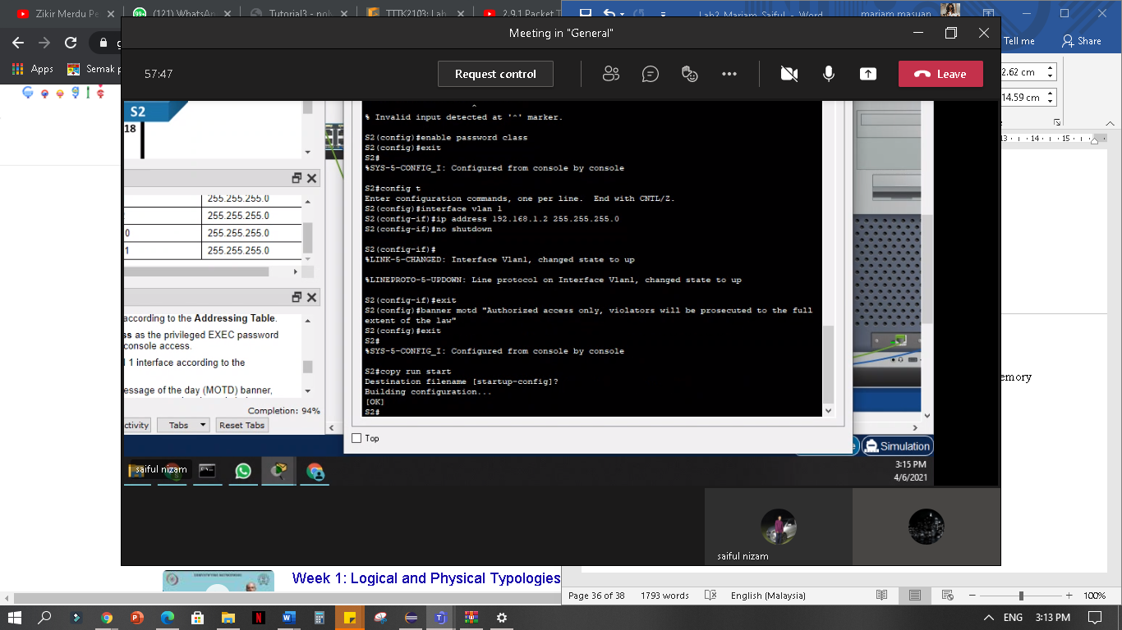

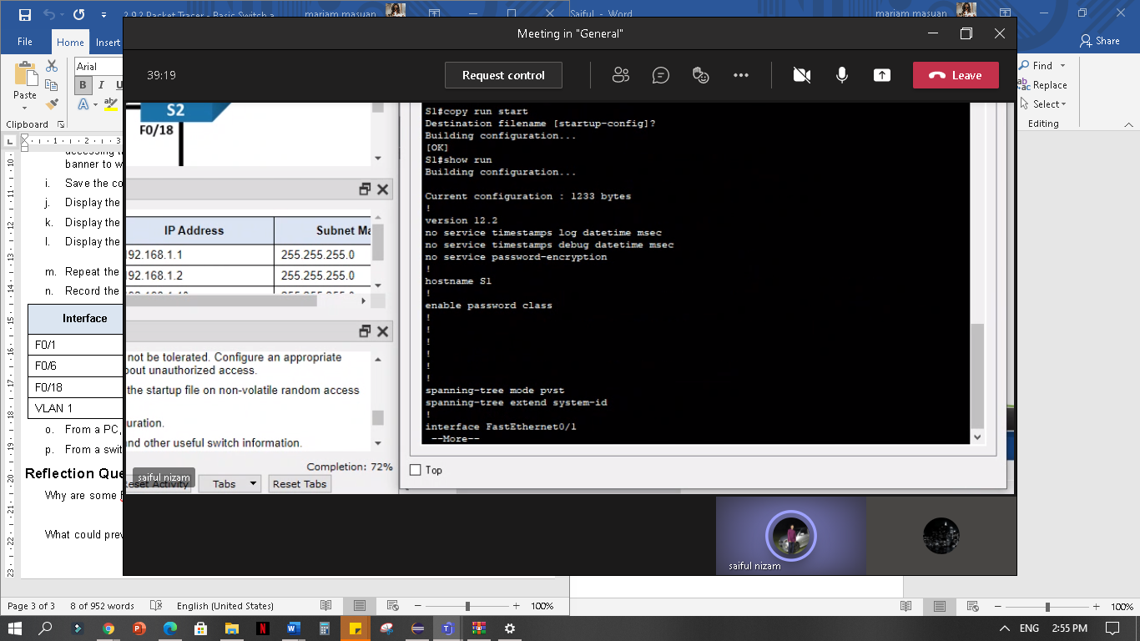**j. Display the current configuration.**

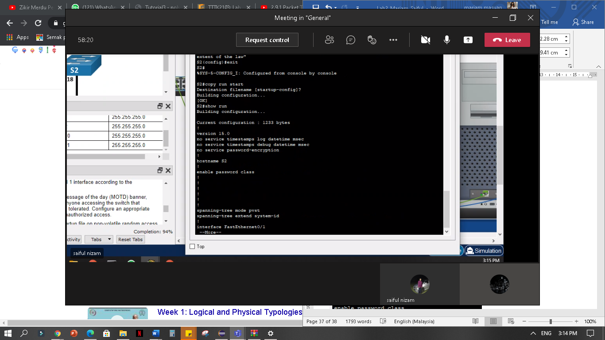

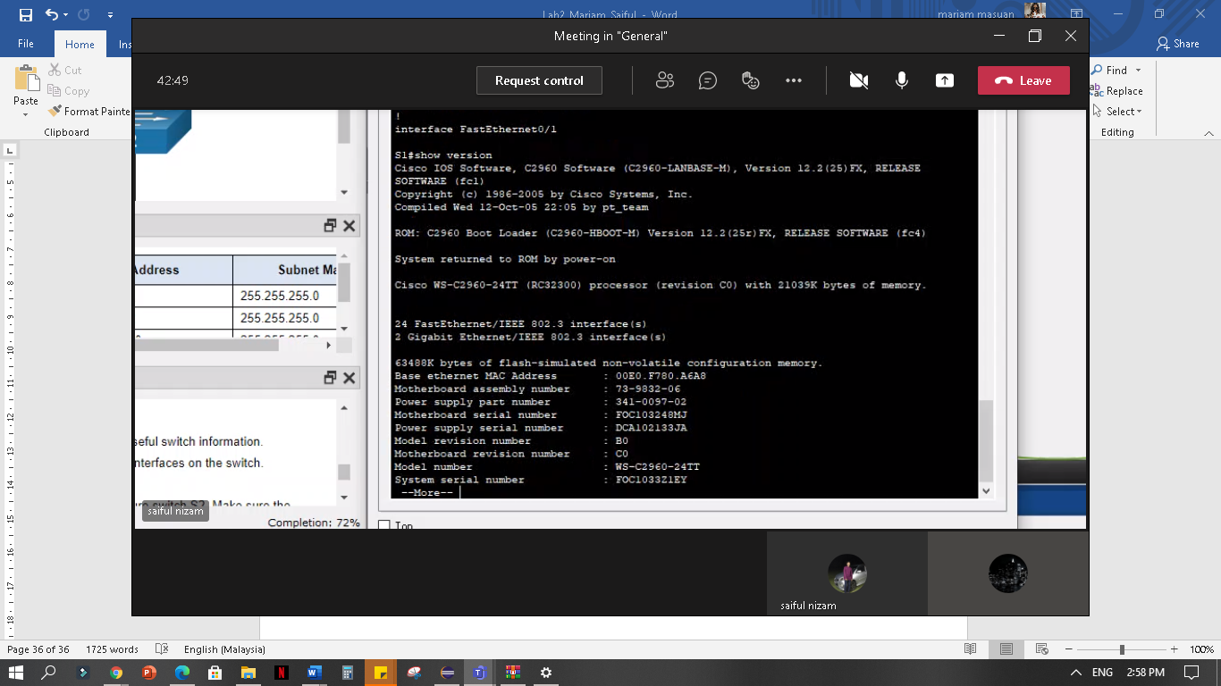**k. Display the IOS version and other useful switch information.**

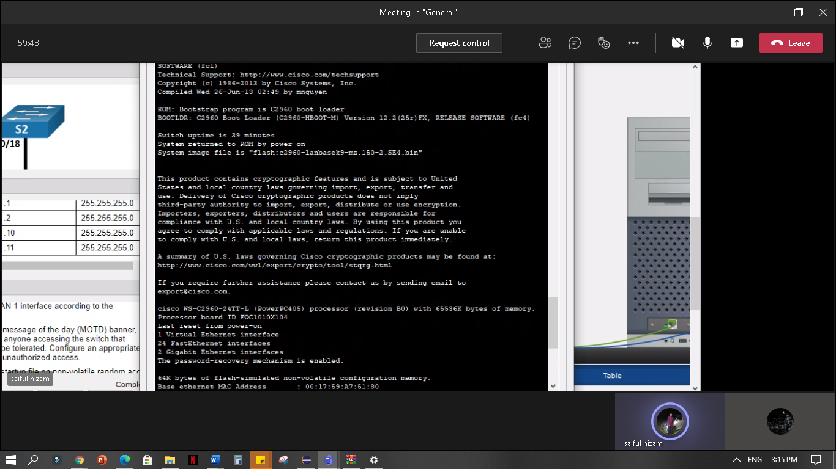

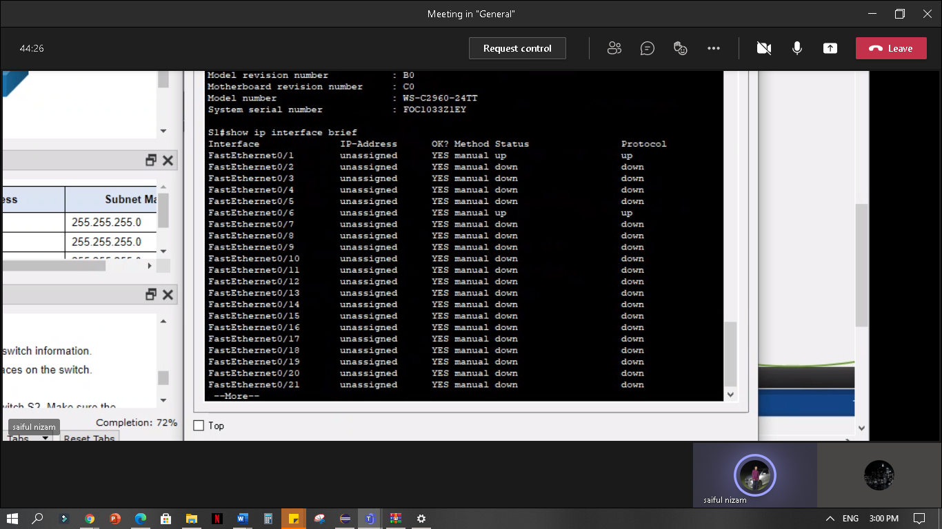**l. Display the status of the connected interfaces on the switch.**

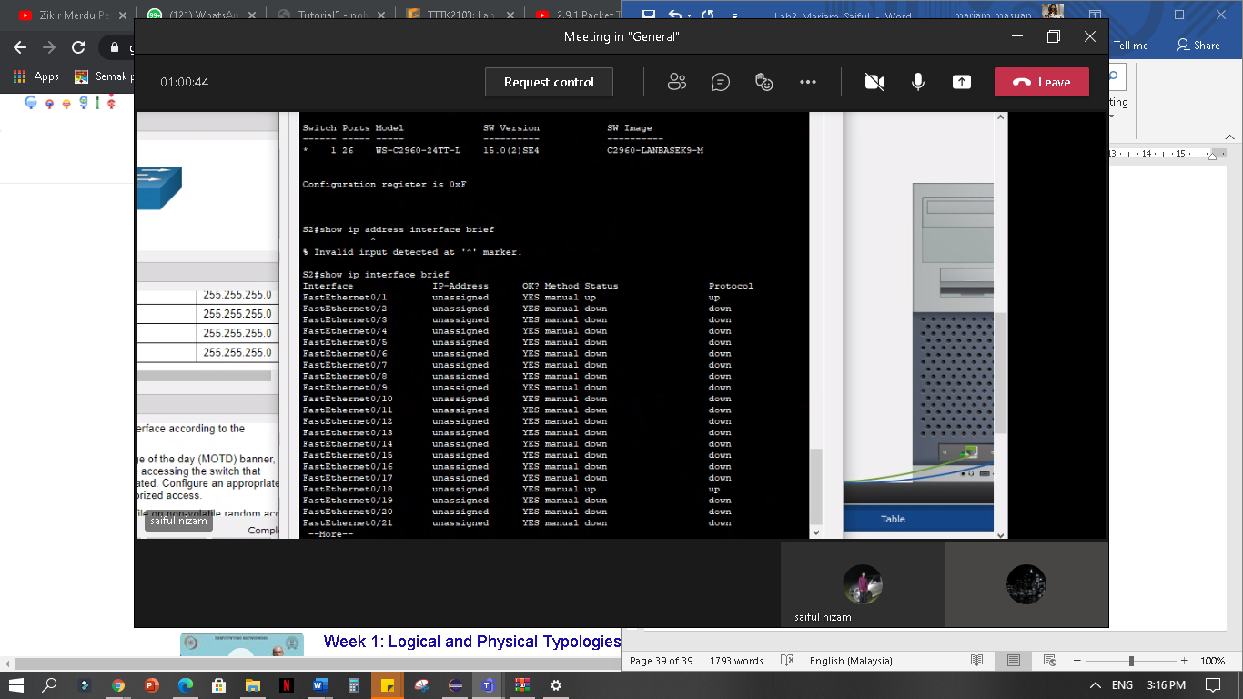

**n. Record the interface status for the following interfaces.**

| Interface | S1 Status | S1 Protocol | S2 Status | S2 Protocol |
| --- | --- | --- | --- | --- |
| F0/1 | Up | Up | Up | Up |
| F0/6 | Up | Up | Down | Down |
| F0/18 | Down | Down | Up | Up |
| VLAN 1 | Up | Up | Up | Up |

**Reflection Question**

**Why some FastEthernet ports on the switches are up and others are down?**

The FastEthernet ports are up when cables are connected to the ports unless they were manually shutdown by the administrators. Otherwise, the ports would be down.

**What could prevent a ping from being sent between the PCs?**

Wrong IP address, media disconnected, switch powered off or ports administratively down, firewall.